How successfully did Stresemann tackle Germany’s problems?

Source A. ‘Saviour Stresemann’, drawn by Karl Arnold in 1923
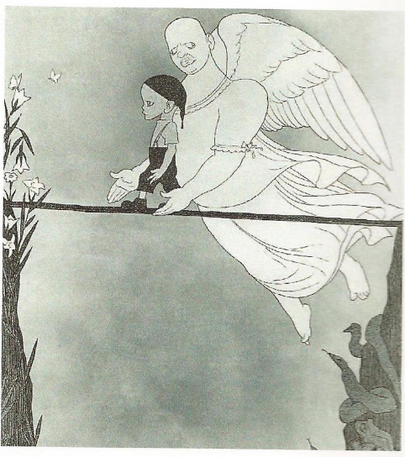

Source B. F Reynoldson, Weimar and Nazi Germany, published in 1996:
“From 1924 to 1929 the Weimar republic was much stronger than it had been just after the war. Led by Stresemann in the Reichstag, the different parties managed to work together. The extreme parties gained fewer seats in the elections. The German people were better off and more contented. The Weimar republic looked safe”

