Questions to Develop Visual Literacy
Review the image below and answer the following questions.

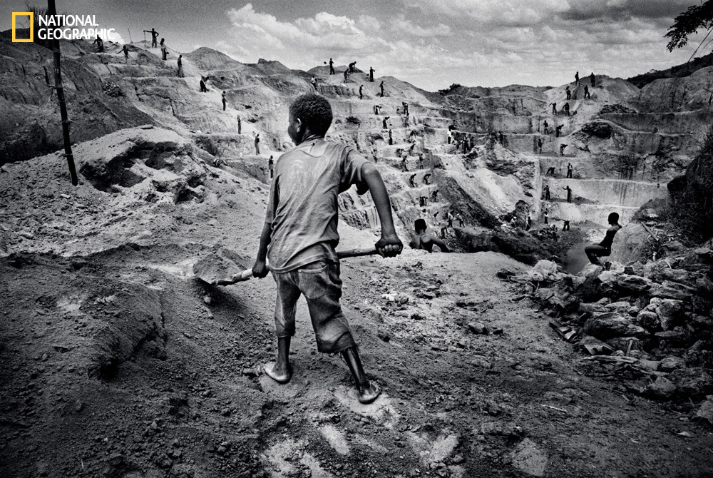

- Where did your eye go first? Then where? Write about why this happened.

- Would you describe the picture as simple or busy? How does this affect the journey your eye took in question 1?

- Where is the light coming from? How can you tell? If this is an outdoor photograph, what time of day might it be? Which are the brightest parts of the picture? The darkest parts? How do the answers to these questions about light affect the mood of the picture?

- Look harder at the photograph. List some of the details you might not have noticed at first. Include information about people, places and things and nature, including the climate or the weather.

- How do the answers to question 4 help you know where and when the photograph was taken? What do they tell you about the people in the photograph?

- What can’t you see or would you like to see to have a better concept or understanding of what is happening in the photo?

- Where is the photographer? Is he or she above, below or at the same level as the subject of the picture? Is he or she near or far away? What kind of information do you get because of these things? What kind of information might you get if the photographer were closer up or further away?

- Keeping all these things in mind, if you had to write a caption, which expressed in one or two sentences what this picture is about, what would you say?

- In your opinion, why did the photographer want you to see this picture?

Taken from http://newdeal.feri.org/classrm/partr2.htm

