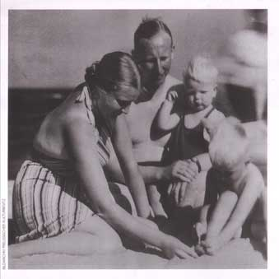
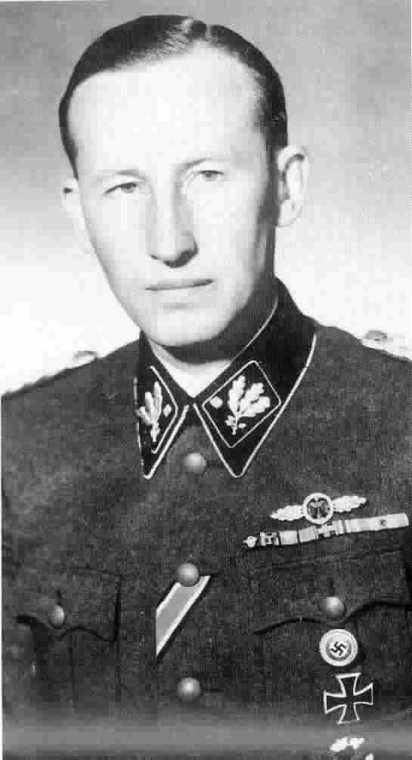
Reinhard Heydrich

The man in these photographs is Reinhard Heydrich.

Heydrich was responsible for organising the murder of all the Jews in Europe.

In 1939 Heyridrich ordered Jews in Poland to be imprisoned in ghettos (areas of towns that were sealed off by walls and fences.

Heydrich gave orders to the Einsatzgruppen (killing squads) as they moved into Russia. The Einsatzgruppen were responsible for most of the mass killings of Jews before the camps were built.

Heydrich planned the sites for the Nazi death camps and, in 1942, helped to organised how Jews would be sent to these camps from all over Europe.

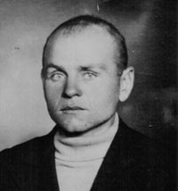

Leopold Socha

The man in the photograph is Leopold Socha, a criminal turned sewer worker who lived in the Polish city of Lvov. In the summer of 1943 the Nazis deported the Jews of Lvov to the death camps. To escape, a Jew named Ignacy Chiger dug a tunnel from his room to the sewers beneath the city. Leopold Socha and three other sewer workers found them hiding there. They knew that helping Jews to hide from the Nazis was punishable by death, and also that the Nazis rewarded those who betrayed Jews in hiding. But, in return for payment, Socha and the others found these Jews hiding places in the sewer network and brought them food, water and news. When the money ran out, Socha continued to help them anyway. Every day he brought them food and once a week he took away their dirty clothes and washed them. Ten of the group survived for nearly a year with Socha’s help. When the German army finally retreated from Lvov it was Socha who led the Jews out of the rat-infested tunnels.

Perhaps 200,000 Jews survived in hiding thanks to the courage of those who risked their lives to give them shelter, food and clothes. However, many tens of thousands of Jews in hiding were betrayed to the Nazis. It is estimated that 1 in 3 Jews in hiding didn’t survive. About 1000 rescuers were executed for helping Jews in hiding, and many more were sent to concentration camps.

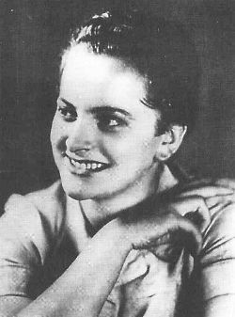
Irma Grese

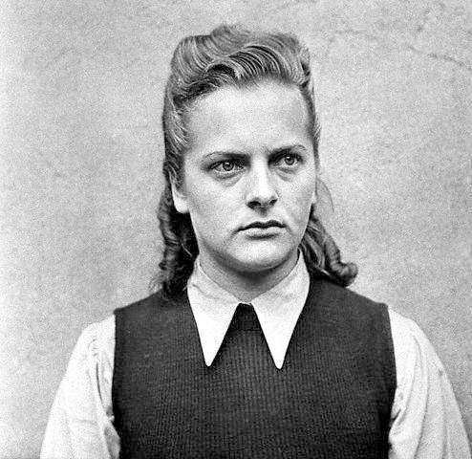

Irma Grese was born in 1923 to a working-class German family. Her mother died when Irma was just 13 and her father, a farm worker, was left to raise their four children on his own.

Irma was attracted to the Nazi movement at a young age but her father forbade her from joining the Nazi organising ‘The League of Germany Girls’. However, she eventually defied her father’s wishes and became an SS guard, first at Ravensbruck, a prison camp for women, and then at Auschwitz and Bergen-Belsen, where Jews were killed.

Irma told her sister that she was a camp supervisor working in a sort of prisoner post office. But in fact she was a vicious guard who actively inflicted pain on her prisoners, beating them with a whip and walking stick. She also shot prisoners herself, and helped to select victims for the gas chambers.

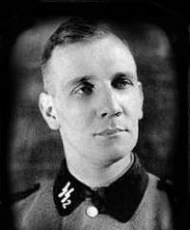

Kurt Gerstein

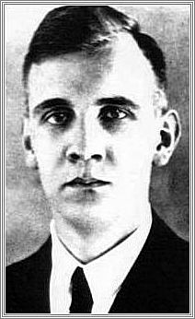
This is Kurt Gerstein. Although the first photograph shows him in his SS uniform, he was not a Nazi. Gerstein joined the SS in 1941 to find out if rumours about the murder of people with mental and physical disabilities were true.

In the summer of 1942 he visited two Nazi death camps and witnessed the murder of Jews in the gas chambers of Belzec and Treblinka. Gerstein tried hard to smuggle information about what was happening to the outside world.

Although Gerstein managed to get detailed information about the death camps to Sweden, a neutral government, the Swedish government kept his reports secret as it did not want Sweden to be drawn into the war.

Gerstein then managed to get the Dutch resistance to broadcast his report to Britain by radio, but British officials dismissed the information as exaggerated and untrue, even though the British government already had information which proved Gerstein correct.

Finally, Gerstein contacted both the Roman Catholic and the Protestant Churches in Berlin, but both failed to public condemn the Nazi treatment of the Jews.

In 1945, in despair, Gerstein committed suicide.
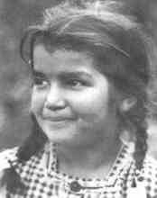
Amalie Schaich

Amalie and her family were gypsies. The Nazis believed that the gypsies were inferior, and were criminals.

When she was 9 years old, the Nazis took Amalie and her brothers and sisters away from their parents and put them in children’s homes. Amalie’s parents were sent to the death camps. For a while Amalie received letters from her parents, though lots of the writing was crossed out by the Nazis so her parents couldn’t tell her the truth.

In 1944 Amalie and 40 or so other children were deported to Auschwitz. Amalie survived the war. She was one of only 2000 gypsies sent to Auschwitz who survived.

During the Holocaust, the Nazis murdered at least 200,000 gypsies from across Europe.

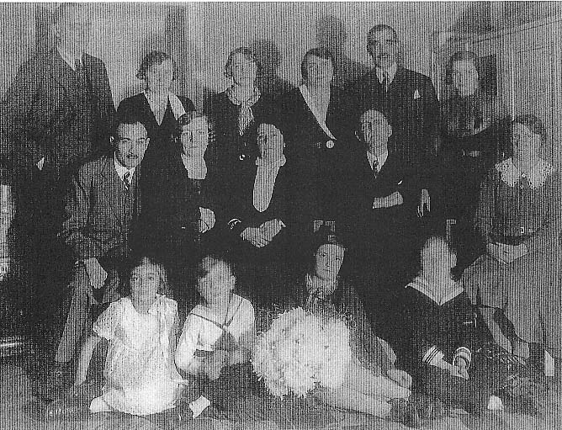
The Bondi Family

This photograph shows Marie Bondi surrounded by her children and grandchildren. Marie Bondi was a Christian who had married a Jew. Her husband had died before the war, but her four children – considered Jewish under Nazi law – were all deported with their families from their home in Moravia. In the back of her Bible, Marie kept a record of the dates they were sent away; her son Willi, who was imprisoned as a homosexual and Jew, was sent to Auschwitz; her daughters Mina and Julie and their children to Terezin; and her daughter Elsa to an ‘unknown destination’.

