What Impact did Joseph McCarthy have on the Red Scare? – Part One: McCarthy’s Accusations
Background
First elected as a U.S. Senator from Wisconsin in 1946, few noticed Joseph McCarthy during his first three years in the Senate. All that changed when in February 1950 he made a bombshell speech. Addressing the Republican Women's Club of Wheeling, West Virginia, he announced that he had evidence that in spite of the Truman administration's efforts to eliminate disloyal elements from government service, 205 members of the Communist Party continued to work for the State Department.
It is likely that even McCarthy himself was surprised at the public reaction to his revelations. In the past two years the United States had watched as China had become a communist country, the Soviet Union successfully tested an atomic bomb, and North Korea launched an invasion of South Korea. America, which had seemed the world's dominant power in 1945, felt its position slipping away, and McCarthy's accusations provided a convenient explanation.
The Senate, therefore, was inclined to look into these charges, and a committee was soon set up under Maryland Democrat Millard Tydings. The charges, Tydings concluded, were without foundation, but few were paying attention. Three days after the Maryland senator publicly rejected McCarthy's accusations Julius Rosenberg was arrested for passing atomic secrets to the Soviet Union. The issue of Soviet penetration of the U.S. government seemed shockingly real. As for Tydings, when he stood for reelection later that year McCarthy and his allies accused him of being "soft on communism." Marylanders took the charge seriously—Tydings, who had been in the Senate since 1927, was defeated.
The message sent by the Tydings defeat was clear—it was dangerous to stand in the way of Joe McCarthy. For the next two years the accusations flew, and quite a few Democrats (and even some Republicans, such as Margaret Chase Smith of Maine, who dared criticize the senator from Wisconsin) found themselves accused of being "communist sympathizers." In 1952, aided in part by McCarthy's accusations (but probably more so by the stalemated war in Korea), the Republican Party won control of both houses of Congress, while GOP candidate Dwight D. Eisenhower was elected president in a landslide.
In the short term at least, Republican dominance in Washington gave McCarthy new prestige and power. He was awarded the chair of the Permanent Subcommittee on Investigations, and used his position to subpoena a series of government employees. His accusations did not remain limited to the State Department. Soon employees of Voice of America, and even officers and enlisted men of the U.S. Army, were called before McCarthy's committee and accused of being at best naïve dupes of communism, and at worst traitors to their country.
In the long run, however, Republican control of Congress and the White House led to McCarthy's downfall. Many Republicans had privately expressed doubts about McCarthy's reckless accusations, but had remained silent when his targets were Democrats. Among these was Eisenhower himself, who had refused even to defend his former Army colleague George C. Marshall when McCarthy suggested that he was a subversive. However, after 1952 the Wisconsin Senator was becoming more and more of an embarrassment to the GOP. When in 1953 he began to suggest that communists had infiltrated the Army, Eisenhower went on the attack, issuing an order forbidding any member of his administration from testifying before McCarthy's committee.
The final straw came in 1954, when the Army accused McCarthy and his chief lieutenant, Roy Cohn, of pressuring the Army into giving preferential treatment to Cohn's friend G. David Schine. Now it was McCarthy himself who was on the hot seat, and in the resulting Army-McCarthy Hearings, broadcast on nationwide television, the Wisconsin Senator came across as a common bully. Meanwhile, the Army's chief counsel, Joseph N. Welch, finally shamed him with the famous words, "Have you no sense of decency, sir?" In December 1954 he was formally censured by the Senate, which put an end to his investigations once and for all. A painful chapter in America's history had at last come to its close.

Activity 1 – McCarthy’s Accusations
Read through Sources 1-4 and answer the following questions as you go. Be prepared to discuss next lesson:
Question | Answer
1. What information did McCarthy cite to show that America was losing the war against Communism?
2. Explain what McCarthy meant when he said, ‘When a great democracy is destroyed, it will not be from enemies from without, but rather because of enemies from within.’
3. How did McCarthy describe the sorts of people engaged in ‘traitorous actions’ in the United States?
4. What did Truman mean when he claimed that McCarthy was an ‘asset’ to the Kremlin?
5. According to Truman, how did McCarthy fit in with the overall strategy of the Republican Party?
6. Evaluate the five statements by the Republican senators. What was their purpose in issuing these statements?
7. In your opinion, how did partisanship fighting between the Republicans and Democrats interfere with the issue at hand?
8. How does the political cartoon by Herblock portray McCarthy? Why do you think he chose to portray McCarthy this way?
Source 1 – Excerpts from Speech of Joseph McCarthy, Wheeling, West Virginia, February 9th 1950: http://historymatters.gmu.edu/d/6456
[....] Today we are engaged in a final, all-out battle between communistic atheism and Christianity. The modern champions of communism have selected this as the time, and ladies and gentlemen, the chips are down—they are truly down....
Six years ago...there was within the Soviet orbit, 180,000,000 people. Lined up on the antitotalitarian side there were in the world at that time, roughly 1,625,000,000 people. Today, only six years later, there are 80,000,000,000 people under the absolute domination of Soviet Russia—an increase of over 400 percent. On our side, the figure has shrunk to around 500,000. In other words, in less than six years, the odds have changed from 9 to 1 in our favor to 8 to 1 against us.
This indicates the swiftness of the tempo of Communist victories and American defeats in the cold war. As one of our outstanding historical figures once said, “When a great democracy is destroyed, it will not be from enemies from without, but rather because of enemies from within.” [...]
The reason why we find ourselves in a position of impotency is not because our only powerful potential enemy has sent men to invade our shores...but rather because of the traitorous actions of those who have been treated so well by this Nation. It has not been the less fortunate, or members of minority groups who have been traitorous to this Nation, but rather those who have had all the benefits that the wealthiest Nation on earth has had to offer...the finest homes, the finest college education and the finest jobs in government we can give.
This is glaringly true in the State Department. There the bright young men who are born with silver spoons in their mouths are the ones who have been most traitorous...
I have here in my hand a list of 205...a list of names that were made known to the Secretary of State as being members of the Communist Party and who nevertheless are still working and shaping policy in the State Department....
As you know, very recently the Secretary of State proclaimed his loyalty to a man guilty of what has always been considered as the most abominable of all crimes—being a traitor to the people who gave him a position of great trust—high treason....
He has lighted the spark which is resulting in a moral uprising and will end only when the whole sorry mess of twisted, warped thinkers are swept from the national scene so that we may have a new birth of honesty and decency in government.

Source 2 - Excerpt from President Truman’s News Conference at Key West, March 30, 1950: http://historymatters.gmu.edu/d/6456
Q. Do you think that Senator McCarthy can show any disloyalty exists in the State Department?
The President. I think the greatest asset that the Kremlin has is Senator McCarthy....
Q. Mr. President, could we quote that one phrase, “I think the greatest asset the Kremlin has is Senator McCarthy”?
The President. Now let me give you a little preliminary, and then I will tell you what I think you ought to do. Let me tell you what the situation is. We started out in 1945, when I became President, and the two wars were still going on, and the Russians were our allies, just the same as the British and the French and Brazil and the South American countries. And we won the war together....
Then our objective was to—as quickly as possible—get peace in the world. We made certain agreements with the Russians and the British and the French and the Chinese. We kept those agreements to the letter. They have nearly all been—those agreements where the Russians were involved—been broken by the Russians. And it became perfectly evident that they had no intention of carrying out the fundamental principles of the United Nations Charter and the agreements which had been made at Teheran, Yalta, and Potsdam. And it became evident that there was an endeavor on the part of the Kremlin to control the world.
A procedure was instituted which came to be known as the cold war. The airlift to Berlin was only one phase of it. People became alarmed here in the United States then, that there might be people whose sympathies were with the Communist ideal of government—which is not communism under any circumstances, it is totalitarianism of the worst brand. There isn’t any difference between the totalitarian Russian Government and the Hitler government and the Franco government in Spain. They are all alike. They are police state governments.
In 1947 I instituted a loyalty program for Government employees, and that loyalty procedure program was set up in such a way that the rights of individuals were respected. In a survey of the 2,200,000 employees at that time, I think there were some 205—something like that— who left the service. I don’t know—a great many of them left of their own accord....
And then, for political background, the Republicans have been trying vainly to find an issue on which to make a bid for the control of the Congress for next year. They tried “statism.” They tried “welfare state.” They tried “socialism.” And there are a certain number of members of the Republican Party who are trying to dig up that old malodorous dead horse called “isolationism.” And in order to do that, they are perfectly willing to sabotage the bipartisan foreign policy of the United States. And this fiasco which has been going on in the Senate is the very best asset that the Kremlin could have in the operation of the cold war. And that is what I mean when I say that McCarthy’s antics are the best asset that the Kremlin can have.
Now, if anybody really felt that there were disloyal people in the employ of the Government, the proper and the honorable way to handle the situation would be to come to the President of the United States and say, “This man is a disloyal person. He is in such and such a department.” We will investigate him immediately, and if he were a disloyal person he would be immediately fired. That is not what they want. They are trying to create an issue, and it is going to be just as big a fiasco as the campaign in New York and other places on these other false and fatuous issues.
With a little bit of intelligence they could find an issue at home without a bit of trouble!
Q. What would it be, Mr. President?
The President. Anything in the domestic line. I will meet them on any subject they want, but to try to sabotage the foreign policy of the United States, in the face of the situation with which we are faced, is just as bad as trying to cut the Army in time of war.
Source 3 - Statement of Seven Republican Senators, June 1, 1950: http://historymatters.gmu.edu/d/6459
1. We are Republicans. But we are Americans first. It is as Americans that we express our concern with the growing confusion that threatens the security and stability of our country. Democrats and Republicans alike have contributed to that confusion.
2. The Democratic administration has initially created the confusion by its lack of effective leadership, by its contradictory grave warnings and optimistic assurances, by its complacency to the threat of communism here at home, by its oversensitiveness to rightful criticism, by its petty bitterness against its critics.
3. Certain elements of the Republican Party have materially added to this confusion in the hopes of riding the Republican party to victory through the selfish political exploitation of fear, bigotry, ignorance, and intolerance. There are enough mistakes of the Democrats for Republicans to criticize constructively without resorting to political smears.
4. To this extent, Democrats and Republicans alike have unwittingly, but undeniably, played directly into the Communist design of “confuse, divide and conquer.”
5. It is high time that we stopped thinking politically as Republicans and Democrats about elections and started thinking patriotically as Americans about national security based on individual freedom. It is high time that we all stopped being tools and victims of totalitarian techniques—techniques that, if continued here unchecked, will surely end what we have come to cherish as the American way of life.
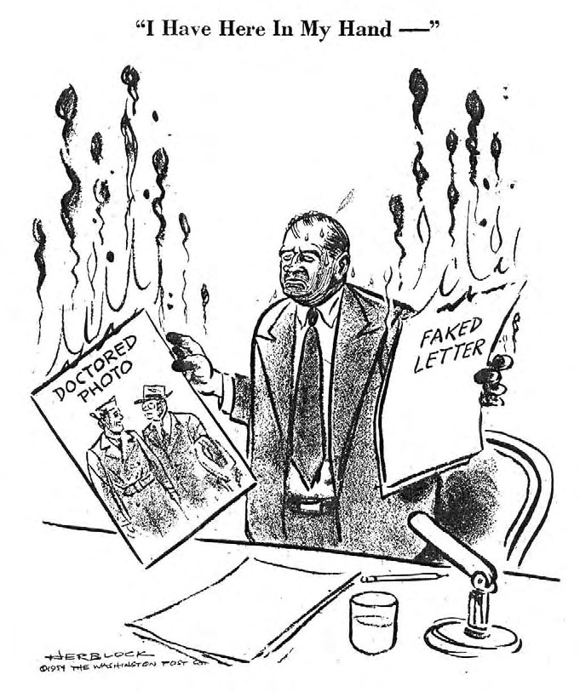
Source 4 - “I Have Here in my Hand...” (Cartoon): http://www.loc.gov/rr/print/swann/herblock/images/s03479u.jpg
"I have here in my hand. . .," May 7, 1954. Ink, graphite, opaque white, and overlay over graphite underdrawing on layered paper. Published in the Washington Post (34) LC-USZ62-126910

