How did Hitler become Chancellor in January 1933?
Complete the table by using pages 70-71 of the textbook. Try to explain the causes and significance (importance) of each event:
Date | Elections and government | Chancellor | Causes | Significance
1932
March and April | Hitler stood for president and lost. | Bruning
May | Nazis asked to join government coalition. | Von Papen
July | Reichstag Election: Nazis now biggest party (230 seats). | Von Papen
November | Reichstag Election: Nazis still biggest party (190 seats) | Von Papen
December | New Chancellor | Von Schleicher
1933
January | New Chancellor | Hitler
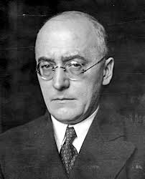
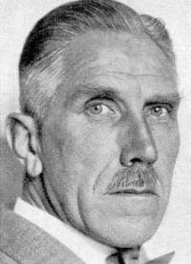
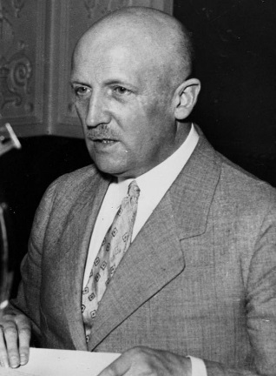
Franz von Papen, Chancellor May-Nov 1932

Heinrich Bruning, Chancellor 1930-1932
Kurt von Schleicher, Chancellor Dec-Jan 1933

