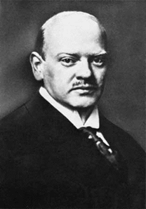
Gustav Stresemann

Good morning Gustav Stresemann and welcome to the Chancellorship of Weimar Germany.
What do you think are the best solutions to the problems of Weimar Germany?

Problem | Your solution | Your score
1. French Troops in the Ruhr.

2. Hyperinflation

3. Poor International Relations
4. German industry was run down
Your Final Score:

The verdict on your solution is:

