The Stresemann Years

Reviewing

TASK

Complete the Table ‘Stresemann Policies – Success or Time Bomb’ that was started last lesson.

Remembering

TASK

Review the this table ‘Stresemann’s Policies – Success or Time Bomb?’ and the PowerPoint on ISLE as well as the table on ‘Problems solved/unsolved after 1924’ that you wrote for homework.

Try and remember as much as you can around the below two areas:

- Achievements
- Problems

The Stresemann Years

Understanding

TASK

Now test yourself! In no more than 10 minutes create a script that briefly summarises the ‘Weimar Republic under Stresemann’. What do you think is important?

Next lesson: You will be using this script and making a video of you and your partner reviewing it.

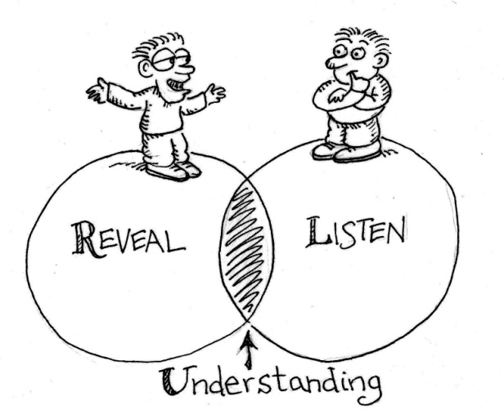
The Stresemann Years

Applying

TASK

For this task you will construct a ‘Tarsia puzzle’. You might be familiar with this in your maths lessons.

Your task is as follows:
- You can use the statements provided or produce your own that focus on the Stresemann years.
- Write each statement on the Tarsia Puzzle as outlined below (half the statement goes on one side of the line, the second half on the other side.
- Once you have added all your statements cut out the triangles.

Next Lesson:
- Your partner will need to match the statements up so that they make sense.
- The statements match up in such a way that they form a large triangle.
- Once completed, check the answers and then stick these onto a plain sheet of paper.
The Stresemann Years

Analysing

The aim of this task is to create discussion and encourage you to work with data to promote a deeper level of understanding.

TASK

- Your task is to translate a table of data into 3 intelligible forms, whether a diagram, a chart, a map based graphic, a newspaper headline… or any other form.
- Imagine you are translating this data for someone who has no knowledge of numbers or raw numerical data. Choose what you believe is important – you don’t need every fact and figure.

