What problems confronted the big 3 in 1919?
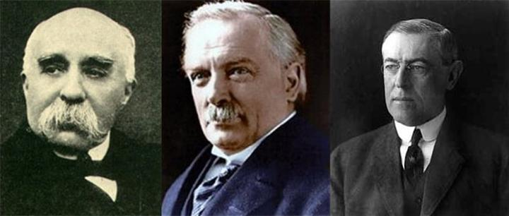

- Voters put pressure on the democratically elected leaders – The English and French public wanted to “Hang the Kaiser” and the Americans wanted a return to “Isolationism
- The Allies had made rash bargains with countries such as Italy and Japan, promising territory after the war in return for the support. Would they have to stick with this?
- The war had completely changed the balance of power. The cost Europe $260 billion dollars, much of which had been loaned by the USA which emerged as the world’s first and only superpower.
- The war had led to a communist revolution in Russia, and the overthrow of the monarchy in Germany, Austria and Turkey; breakaway nations were already forming (e.g. Yugoslavia, Czechoslovakia, and Poland).
- The war ended very suddenly and there was no agreement between the allies about how Europe should be reorganized.
- An influenza pandemic was raging across Europe. Ultimately, this killed more people (30 million) than the war itself! Half of the US soldiers who failed to return died of the flu, not from enemy action!

Create a newspaper headline that summarizes each of these issues
Which of these problems is most serious? Explain your answer by connecting the facts together.

