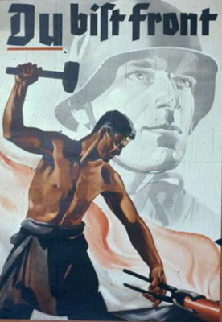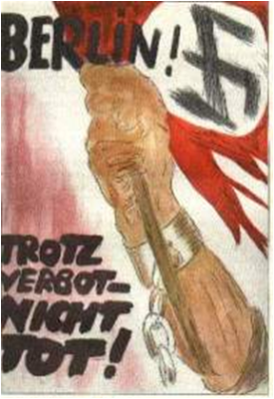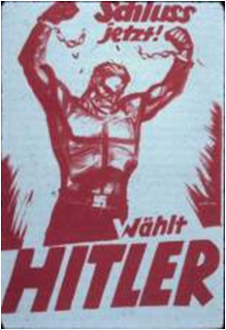

Goebbels plastered Germany with cheap effective posters **proclaiming the success of Hitler and the Nazis and attacking their opponents**. Placed in prominent positions they act as a constant reminder to people.

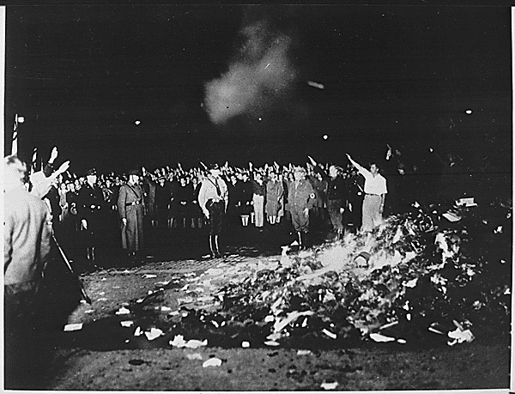

Plays and literature had to **conform to Nazi beliefs** or they could not be performed or published. In this way **undesirable influences such as jazz or Black music, could be kept from the German people**. In **1933** Goebbels organised a **high profile book burning**. Nazis and students came together to burn any **books that included ideas unacceptable to the Nazis**

The cinema was popular so Goebbels **encouraged new films that carried the Nazi message.** Admission to view cinema was only allowed at the start so you has to watch the newsreels before the film.

The Nazis made sure the radio was easily acceptable to all Germans. They were made cheaply as Goebbels believed that this was better than the written word. The radios only had a **short wave frequency so international stations could not be received**. Listening to the BBC was a criminal offence punishable by death. Just in case people did not have a radio **Goebbels placed loud speakers in streets and public bars**. Hitler’s speeches and those of other Nazi leaders were played over and over until the message **- expansion east and inferiority of the Jews – came to be believed by the German people.**

In the next issue there must be a lead article featured as prominently as possible, in which a decision of the Fuhrer, no matter what it may be, will be discussed as the only correct one for Germany.

Instructions to the press by Goebbels

Goebbels controlled the newspapers closely. They were **not allowed to print anti-Nazi ideas**. Within a month of the Nazi takeover, Jewish editors and journalists found themselves out of a job and **anti-Nazi papers were shut down**. **Journalists** were also given detailed **instructions of what to write.**



The greatest propaganda coup for Hitler came in 1936 when the Olympic Games were held in Berlin. The games were used to promote **German technical efficiency and supremacy** **of the Aryan race**. A brand new **stadium** was built holding **100,000 spectators, and television cameras** were used for the first time. Foreign visitors were highly impressed with the **excellence of the facilities** and the **efficiency of the organisation**. Of course Hitler ensured that the negative sides of Nazism, such as restrictions on personal freedom and the mistreatment of the Jews, were kept in the background.

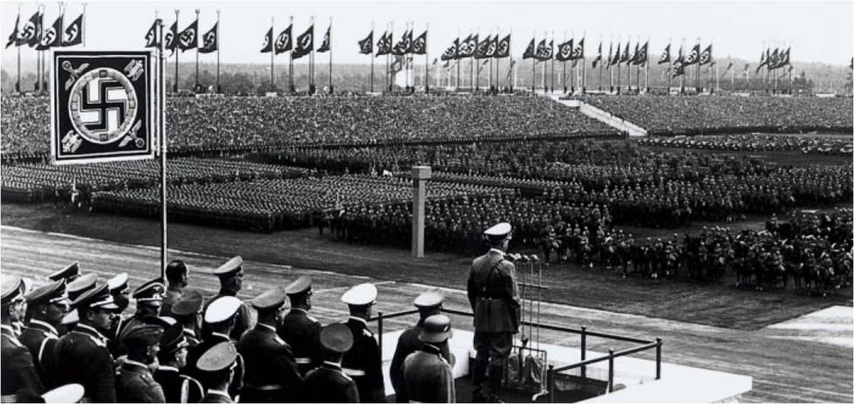

Goebbels organised huge rallies. Probably the best example was the **Nuremburg rally** which took place in the summer each year. There were bands, marches, flying displays and **Hitler’s brilliant speeches**. The rallies brought some colour and excitement into people’s lives.

They gave them a sense of belonging to a great movement. Goebbels also recognised that one of the Nazi’s main attractions was that they created **order out of chaos** and so the whole rally was organised to emphasise order.